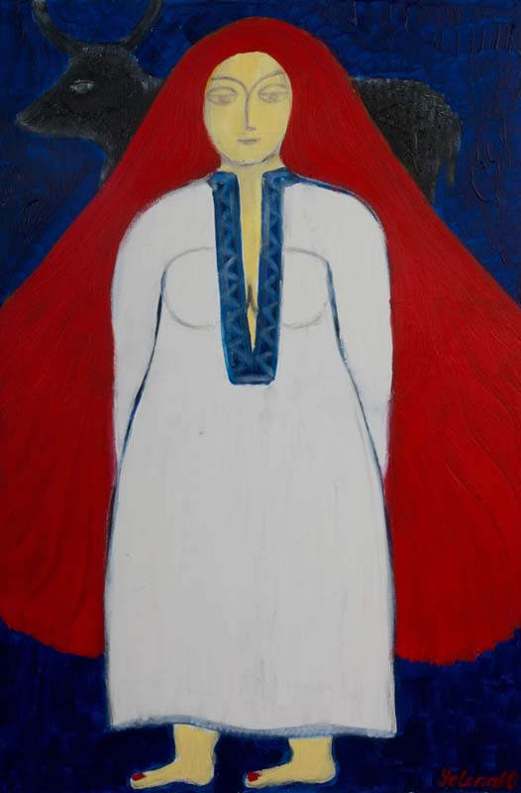

Yelena’s Gallery May 4, 2013

Friday night Concerts 7:30 PM

**Raehann Bryce Miriam Leskis**

Mezzo-soprano Piano

**Women’s Secrets**

Ravel Sheherazade

Schumann Frauenliebe und Leben

Argento From the Diary of Virginia Woolf

Addmission 40$

2 Archbridge Lane, Springfield NJ 07081

Tel: (917)-981-0154; (973)-953-9093