Seasons  Miriam Leskis – Piano  P. Tchaikovsky  - January: At the Fireside  - February: carnival  - March: Songs of the Lark  - April: Snowdrop  - May: Starlit Nights  - June: Barcarolle  - July: Song of the Reaper  - August: Harvest  - September: The Hunt  - October: Autumn Song  - November: Troika  - December: Christmas | Yelena’s Gallery  Friday Nights Concert Series  January 10 & 24* 7:30PM  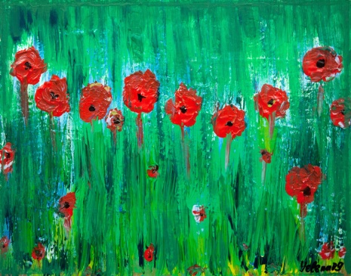 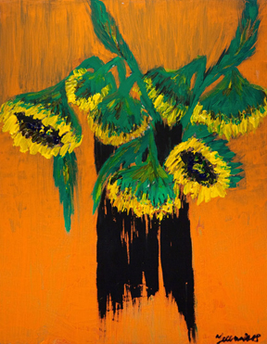  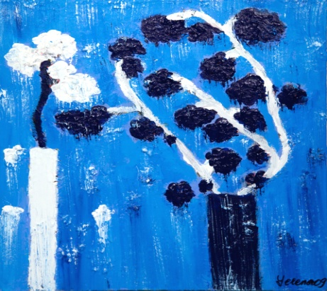 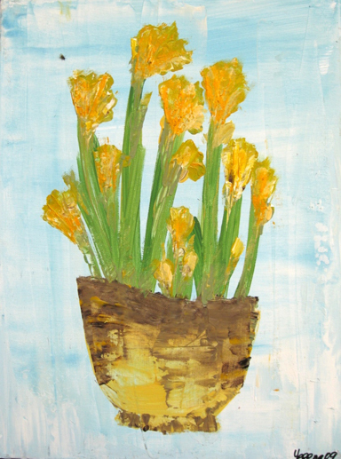  Yelena’s Gallery  2 Archbridge Lane, Speingfield, NJ, 07018  Tel: 917-981-0154; Tel: 973-953-9093

