Childhood
Fleur Barron – Mezzo Soprano
Miriam Leskis - Piano

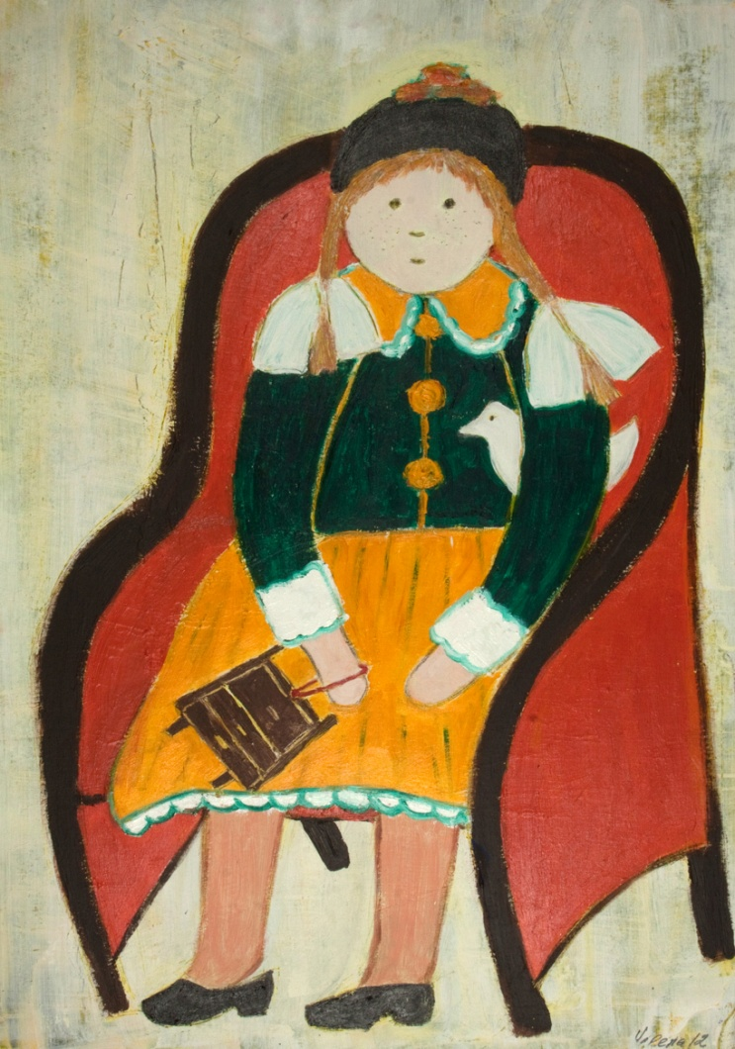
*repeated program

Mussorgsky – Nursery
Schumann – Kinderszenen Op. 15

Childhood

Mussorgsky – Nursery
With Nanny
In the Corner
The Beetle
With the Doll
At Bedtime
Ride on a Hobby Horse
The Cat ‘Sailor
Schumann – Kinderszenen Op. 15
- Von fremden Ländern und Menschen (Of Foreign Lands and Peoples)
- Curiose Geschichte (A Curious Story)
- Hasche-Mann (Blind Man's Buff)
- Bittendes Kind (Pleading Child)
- Glückes genug (Quite Happy)
- Wichtige Bebebenheit (An Important Event)
- Träumerei (Dreaming)
- Am Camin (At the Fireside)
- Ritter vom Steckenpferd (Knight of the Hobby-Horse)
- Fast zu ernst (Almost too Serious)
- Fürchtenmachen (Frightening)
- Kind im Einschlummern (Child Falling Asleep)
- Der Dichter spricht (The Poet Speaks

