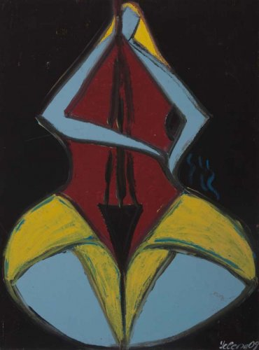

Yelena’s Gallery October 5, 2012

Friday Night Concerts 7:30 PM

**Simon Hoffmann** **Miriam Leskis**

Cello Piano

**Cello Passion**

**Beethoven** Theme and Seven Variations

"Bei Mannern" WoO 46

**Ligeti** Cello Sonata

**Beethoven** Sonata No. 3 for cello and piano

A major Op. 69

Addmission 40$

2 Archbridge Lane, Springfield NJ 07081

Tel: (917)-981-0154; (973)-953-9093