Yelena’s Gallery
Friday Night Concert Series
Le Bestiaire

Fleur Barron – Mezzo Soprano
Miriam Leskis - Piano
Yelena's Galley season 2013-2014
Le Bestiaire
Fleur Barron - mezzo soprano
Miriam Leskis- piano

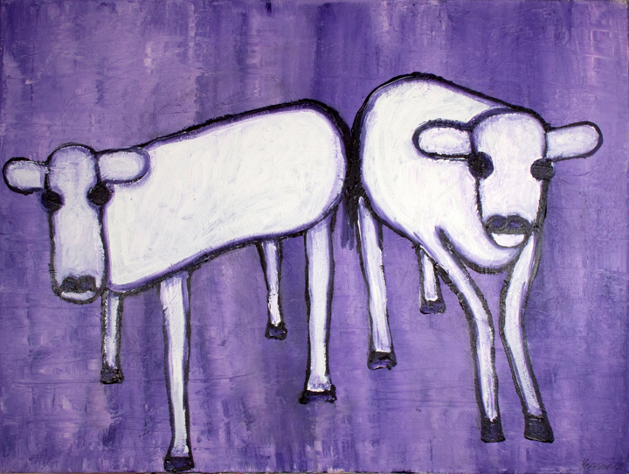October 4 & 18, 2013
7.30 PM
2 Archbridge Lane, Springfield NJ 07081
F. Poulenc – Le Bestiaire
Le dromadaire (The Dromedary)
La chèvre du Thibet (The Tibetan Goat)
La sauterelle (The Grasshopper)
Le dauphin (The Dolphin)
L'écrevisse (The Crayfish)
La carpe (The Carp)

R Schumann – Papllons (selection)

M. Ravel – Histoies Naturelles
Le paon
Le grillon
Le cygne
Le martin-pêcheur

