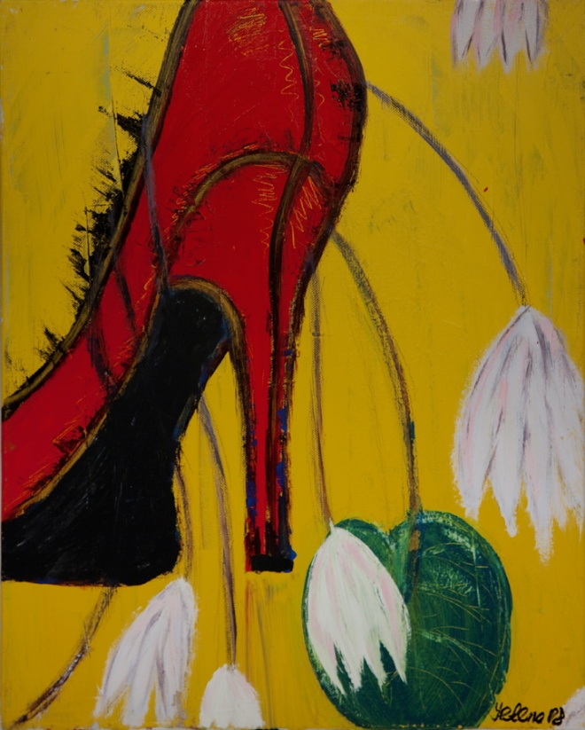
Yelena’s Gallery
Friday Night Concert Series
March 7 & 21*, 2014 7:30PM

Cabaret Songs
Fleur Barron - Mezzo Soprano
Miriam Leskis - Piano

Arnold Schoenberg
John Duke
Charles Trenet
Benjamin Britten

Yelena’s Gallery
2 Archbridge Lane Springfield, NJ 07081
Tel (917)-981-0154; Tel (973)-953-9093

